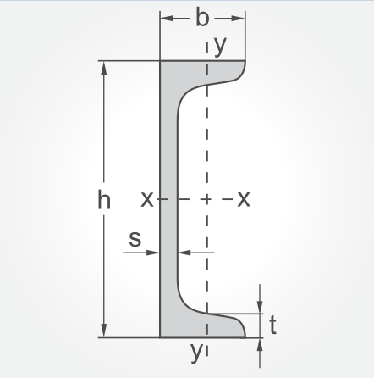

|  |  |  |  |
| --- | --- | --- | --- |
| **UPN- ПРОФИЛИ** | | | |
| **вид** | **тегло**  **за 6 м** | **цена за 6 м**  **с ДДС/в евро** | **цена за 6 м**  **с ДДС/в лева** |
| **U40x20** | **18.00кг** | 21.17 ев | 41.40 лв |
| **U40x35** | **29.60кг** | 34.82 ев | 68.10 лв |
| **U50x25** | **23.40кг** | 27.51 ев | 53.80 лв |
| **U50x38** | **34.00кг** | 39.98 ев | 78.20 лв |
| **U65x42** | **43.00кг** | 50.57 ев | 98.90 лв |
| **U80x45x6** | **54.60 кг** | 61.41 ев | 120.10 лв |
| **U100x50x6** | **65.80кг** | 74.04 ев | 144.80 лв |
| **U120x55x7** | **83.50кг** | 93.92 ев | 183.70 лв |
| **U140x60x7** | **98.40кг** | 110.69 ев | 216.50 лв |
| **U160x65x7.5** | **115.80кг** | 130.28 ев | 254.80 лв |
| **U180x70x8** | **135 кг** | 189.84 ев | 371.30 лв |
| **U200x75x8.5** | **156 кг** | 219.34 ев | 429.00 лв |