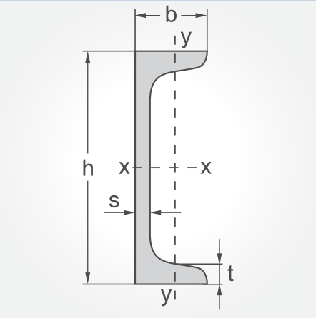

|  |  |  |  |
| --- | --- | --- | --- |
| **UPN- ПРОФИЛИ** | | | |
| **вид** | **тегло**  **за 6 м** |  | **цена за 6 м**  **с ДДС** |
| **U40x20** | **18.00кг** |  | **41.40 лв** |
| **U40x35** | **29.60кг** |  | **68.10 лв** |
| **U50x25** | **23.40кг** |  | **53.80 лв** |
| **U50x38** | **34.00кг** |  | **78.20 лв** |
| **U65x42** | **43.00кг** |  | **98.90 лв** |
| **U80x45x6** | **54.60 кг** |  | **120.10 лв** |
| **U100x50x6** | **65.80кг** |  | **144.80 лв** |
| **U120x55x7** | **83.50кг** |  | **183.70 лв** |
| **U140x60x7** | **98.40кг** |  | **216.50 лв** |
| **U160x65x7.5** | **115.80кг** |  | **254.80 лв** |
| **U180x70x8** | **135 кг** |  | **371.30 лв** |
| **U200x75x8.5** | **156 кг** |  | **429.00 лв** |